Day in the Life of the Hudson River 10/13/22
Pier 40 at Hudson River Park, NYC
RIVER MILE: 2.9
Salt Front: ~ RM 76
Hudson River Project– Toland Kister, The Museum School – Scott Wassmuth
38 students & 6 adults
Latitude 40.72842 N & Longitude – 74.01379 W
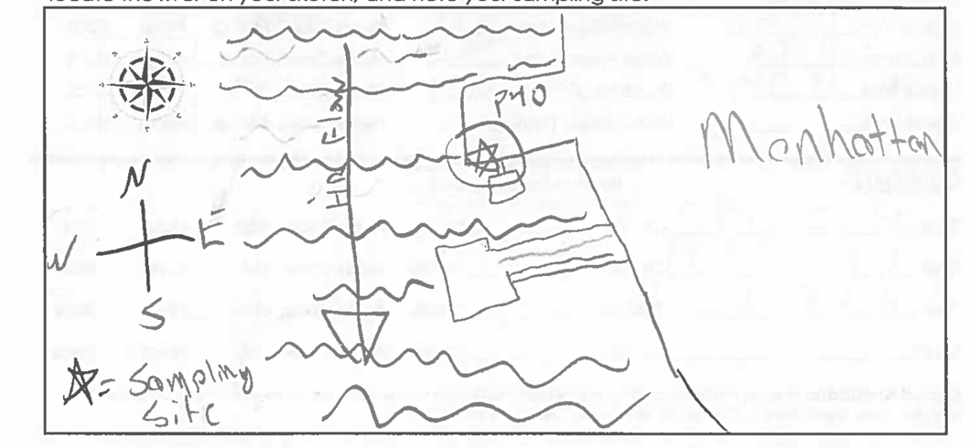
Location: Pier 40 at Hudson River Park, NYC
Area: South-facing walkway on Pier 40 over the water; primary sampling happened between grey floating dock and send of pier
Surrounding Land Use: Urban/Residential; Park
Sampling Site: Concrete Bulkhead
Shoreline: N/A
Water: Choppy
Plants in area: No plants in the water
*NR = Not read/recorded
ITEM |  | Time |  | Reading |  |  |  | Comments
Physical
Air Temperature- |  | 10:00 AM |  | 20°C |  |  | 68°F
Wind Speed: |  | 10:53 AM |  | Anemometer  NR |  |  | Beaufort  5 | Direction  NR
Weather today |  | 11:00 AM |  | >75% cloud cover |  |  | Small amount of rain at end of the day
Weather the past 3 days: |  | Sunny
Tides- |  | Time |  | Rising, Falling, Unchanged |  |  | Water Height (cm)
 |  | 10:27 AM-10:42 AM  10:42 AM-11:24 AM |  | Rising  Falling |  |  | 225 cm  250 cm  250 cm  247 cm
Current- |  | Time |  | Cm/sec |  | Knots | North/South | Ebb/Flood/Still
 |  | 10:33 AM  11:17 AM  11:45 AM |  | 14.7  17.24  60 |  | NR | NR | Slack  Slack  Ebb
Water Temperature- |  | 10:29 AM  10:46 AM  11:07 AM  11:27 AM |  | 17°C  18°C  16°C  18°C |  |  | 62°F  63°F  60°F  65°F
Turbidity- Turbidimeter (NTU) |  | 11:11 AM  11:30 AM |  | 107 NTU  77 NTU
Chemical
Salinity-Hydrometer |  | 10:34 AM  10:50 AM  11:05 AM  11:30 AM |  | 19/21/22 ppt  22/18/22 ppt  22/18/21 ppt  21/23/23 ppt |  |  | 21.25 ppt  21.75ppt  20.25 ppt  22.25 ppt
Standardized Salinity – Refractometer |  | 11:40 AM |  | 24,000 ppm
DO – Chemets |  | Time  10:39 AM  10:57 AM  11:21 AM |  | Temp  17°C  17°C  17°C |  |  | ppm DO  5.5 ppm  6 ppm  7 ppm | % saturation  NR  NR  72%
pH – NR
Nitrates- NR
Phosphates- NR
Alkalinity- NR
Biological-
Fish – Traps |  | Number |  | Name |  |  | Length of longest | Length of smallest
 |  | 1 |  | Black Seabass |  |  | 8 cm
Fish Totals |  | TOTAL:1 |  | Diversity: 1
Macroinvertebrates |  | Number |  | Name |  |  | Length of longest | Length of smallest
Macroinvertebrate Totals |  | TOTAL: 0 |  | Diversity:0
Sediment Core – from a grab sample not a core
Length | H2S smell |  | Oxid Top |  | Oil |  | Grain Size | Other Features
NR | Yes |  | Yes |  | No |  | Abundant: mud  Rare: gravel, pebbles | Common: shells  Rare: leaves, wood, macroinvertebrates
Boats-NR
 | Time |  | Name |  | Color |  | North/Southbound | Light/Loaded

